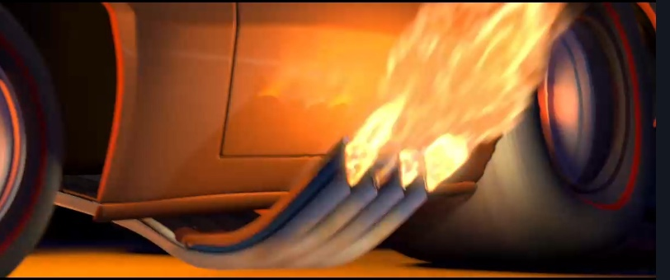

ESSAY

Anton Kuznetsov

IVT 4.1

I think home need to be that place in which you will feel yourself calm and privacy. Home is place where you can be yourself, where you can take a break from another world. That place, i think, should to include your dreams, cause home – it’s your world, where your rules are set. Also, with your growing up you always change your home, that changes may be good for you or not, but anyway they will. You can be always in progress about your dream house, and maybe sometime you will finish your house! With digital progress, we have many options about house upgrade like smart robot vacuum cleaner, voice assistant, smart safety system and more, that give to you unlimited possibilities about your dream future house, by the way, i think, enough for me only smart vacuum cleaner, cause i like clean floor.

I am impressed by falling water house, because he placed in the forest, also his design based on classical Japanese tea house and farm house architecture, in which space is altogether more permeable and fluid, not walled off but divided by sliding screens. I think, a falling water house design so that being in it, a person experiences peace.

In future we will lived in smart houses, because it’s gonna be cost less than now and will be more variations of smart thing. And i think it good tendent and same not good. Smart houses will make easier our life, like we can give our tasks to robot which do job instead us, walking with dog, cooking, cleaning house and etc. Yes, its impressive humans will save many time, but i think we need that routine in our life, cause that helps to our brain relax, we rest when we change activities. Without routine we maybe will start to degrade. Also in digital houses, our privacy can be violated. And last problem about energy, cause the more digitals in world the more energy consumption.